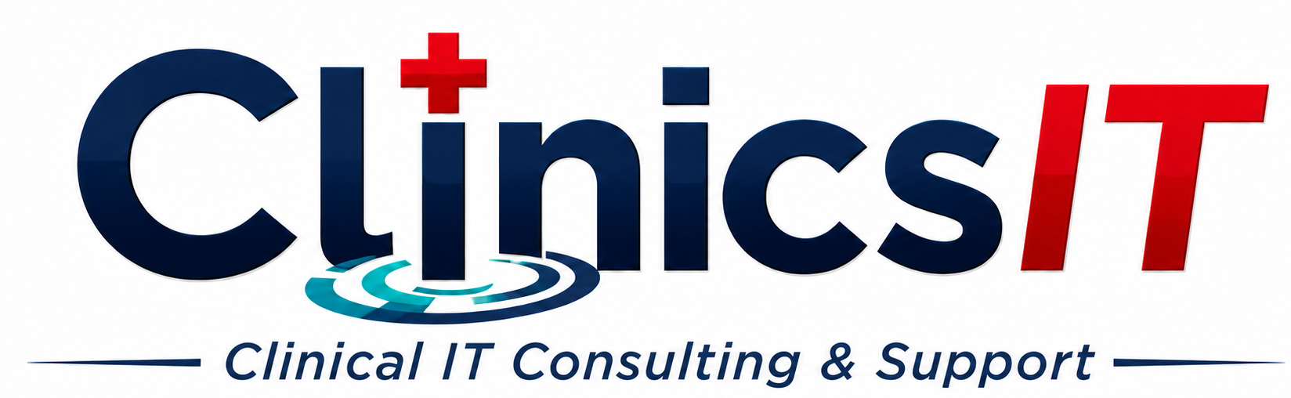 | SMALL CLINIC IT SUPPORT
LOCAL IDAHO CLINICAL IT SUPPORT

Dependable IT help without a full-time internal IT employee.
ClinicsIT supports independent clinics and small healthcare organizations with practical technology support, project work, and ongoing oversight throughout the Treasure Valley and nearby Idaho communities.
Everyday support  Computers, Microsoft 365, Google Workspace, Zoho Workplace, printers, scanners, accounts, and staff access. | Projects and improvements  Computer deployment, network and Wi-Fi upgrades, backups, documentation, vendor coordination, and office changes. | Ongoing support  A dependable local point of contact for clinics that need continuity without building an internal IT department.

Common reasons clinics contact ClinicsIT
The office manager has become the unofficial IT person; no one knows who controls important accounts; scanners or printers fail after computer changes; backups have never been tested; former staff or vendors may still have access; or the clinic needs one person to coordinate multiple technology vendors.

Why ClinicsIT
- More than 25 years of technology experience and over a decade supporting medical environments.
- Clinic-owned accounts, practical documentation, and clear recovery planning.
- Hourly, fixed-scope project, and ongoing support options.
- Clear scope and pricing before work begins. No patient information or passwords requested through the website.
Schedule a Free 20-Minute Clinic IT Review  Describe the support gap, project, or recurring frustration. ClinicsIT will recommend a practical next step. |   clinicsit.com

